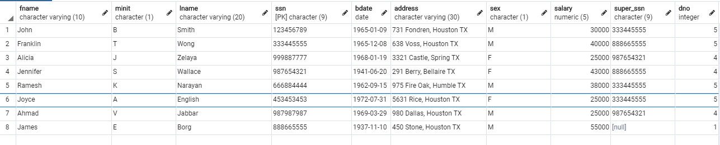EMPLOYEE

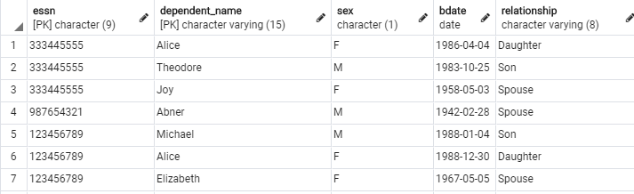DEPENDENTS

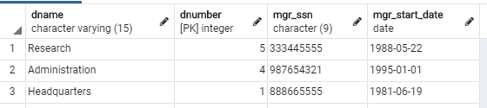DEPARTMENT

DEPT_LOCATIONS WORKS_ON

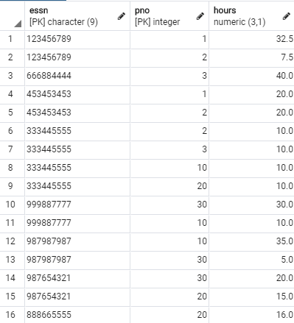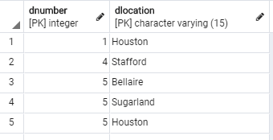

PROJECT

